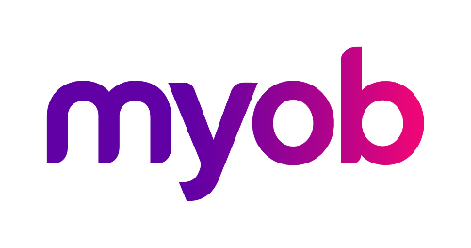
MYOB Greentree
Release Notes
2017.1.0

Contents
Overview 1
New features – Greentree desktop 2
Mobile Timesheet Control Form 2
New features – Greentree Browser 3
Product Catalogue 3
Add Signatures to Service Requests and Calls 5
Enhancements – Greentree Desktop 7
Tax File Declaration Changes for Working Holiday Makers (Australia) 7
Custom Tab Added to JC Job Templates 8
Enhancements – Greentree Browser 9
Enhancements – Greentree Browser and Desktop 10
Inactive Accounts No Longer Visible on Forms 10

Overview
Greentree release 2017.1.0 contains several new features and enhancements in both MYOB Greentree Desktop and Greentree Browser.
In Greentree Desktop, you can now set the options for Greentree Browser timesheets. We've also updated the way Greentree handles Tax File Declarations, based on changes to the way in which the Australian government taxes Working Holiday Makers.
In Greentree Browser, we've added a mobile product catalogue and the ability to add signatures to Service Requests and Calls.

New features – Greentree desktop

Mobile Timesheet Control Form
We've moved the Timesheet Control form to Greentree Desktop from Greentree Browser. This form enables you to set several options that are available for timesheets in Greentree Browser, including:
- Reminders for employees to submit their timesheets
- The minimum and maximum number of hours employees are expected to work
- The action to take if employees haven't worked the minimum or maximum number of hours
- The working calendar the employee uses
- The module to use when submitting or approving timesheet lines
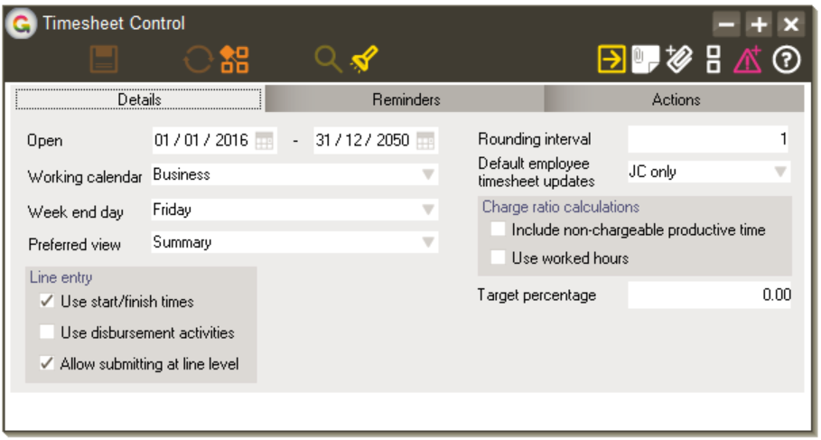
You can find this form under System > System Setup > Mobile Timesheet Control.

New features – Greentree Browser

Product Catalogue
Greentree Browser now includes a product catalogue module. Instead of carrying bulky printed catalogues — which can be lost, damaged, or quickly go out of date — on sales calls, salespeople can now have detailed product information on their tablets.
Using the catalogue is easy: got to Create/Enquire > Supply & Distribution > Selling > Catalogue. On the Catalogue form, select the name of the Organisation you're selling to. Then, select a Product from the list. You'll see:
- An image of the product (if available),
- The product's price,
- A list of substitute products to be used if the selected product is not available, and
- A list of the product's features (if available)

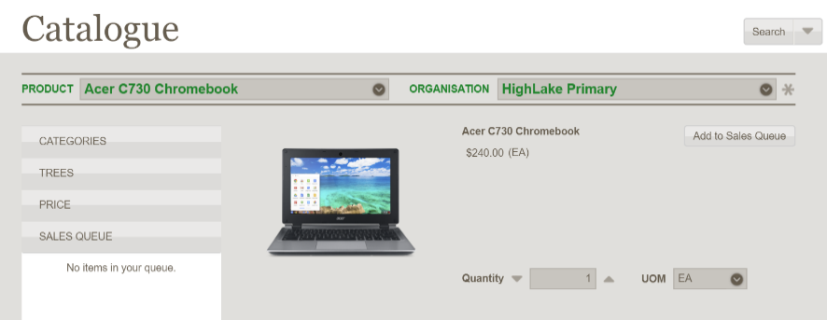

Tap the Add to Sales Queue button to put the currently-visible item in the Sales Queue on the left side of the form. The Sales Queue lists the items, their quantities, and a running total of their prices.
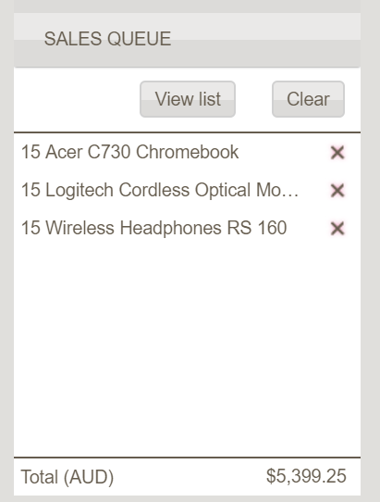
If the Product list contains a large number of items, you can filter it using the following options:
- Categories - A list of product categories
  - Trees - A list of inventory item trees; flagged for catalogue use in Inventory Item Tree Maintenance; which structure and define catalogues
  - A tree may be also be flagged to show as a highlight (e.g. Top seller) by nominating a Highlight tree in Inventory Item Tree Maintenance
- Price - A price range
Tap the Search button to filter items based on those options. Greentree Browser displays the filtered items in a grid, showing the name, price, and quantity of each item and a photo (if available).
For example, your customer wants to buy new computer peripherals for their employees and wants to spend between $20 and $100 dollars for each peripheral. You can set up filters around that price range and for Keyboard and Mice.
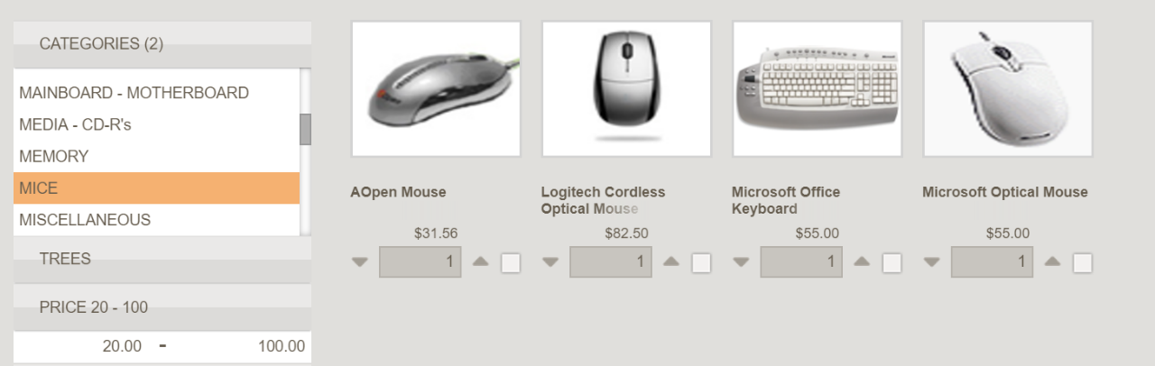

With items in the Sales Queue, you can generate a sales quote or a sales order for the customer. Tap the Smart Button and then tap either Add to Sales Quote or Add to Sales Order to open the Quote or Sales Order form. Greentree populates the quote or order form with information about the products and the customer's details.
- It is possible to customise the returned product list by accessing the asterisk to the right of the Organisation field. This will allow an overriding Price book to be nominated and items with no inventory on hand to be hidden in the results.

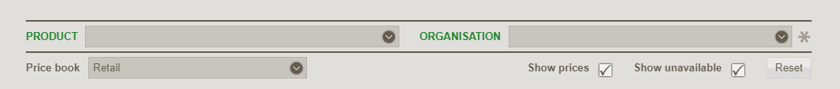
- The contents of the catalogue will vary based on the companies you have access to and what’s been configured in Greentree Desktop under Data Entry > Inventory > Inventory Item Maintenance.

Add Signatures to Service Requests and Calls
The Service Request and Calls forms now include a tab that lets you, a customer, or a manager add a signature to a request or call. You can sign the request using either a finger or a stylus. The signature can indicate a customer's approval or a manager or supervisor's sign off on a service request or call.
You can add multiple signatures to a request or call, edit the details of a signature, or delete a signature.
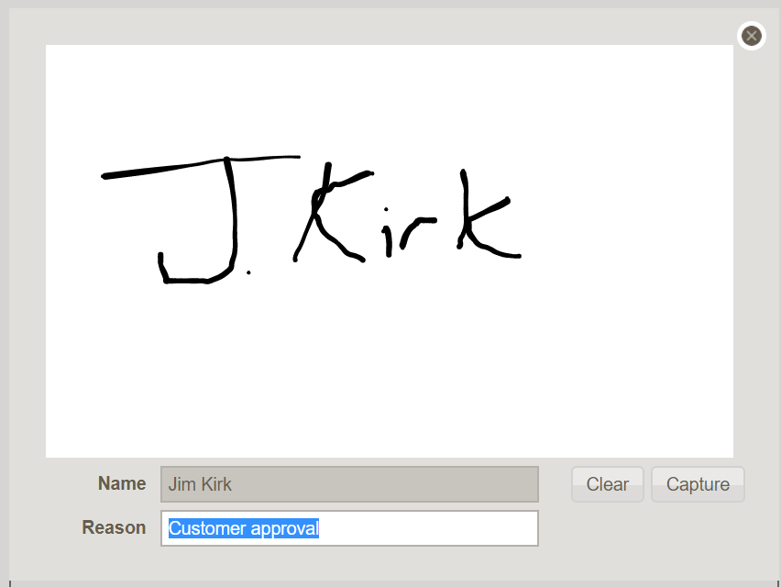
Greentree saves signatures as PDF files, which you can view in the Windows client under CRM > Service Support Service Request / Attachments.
Greentree adds a watermark to the PDF files to prevent signatures from being copied and used elsewhere.
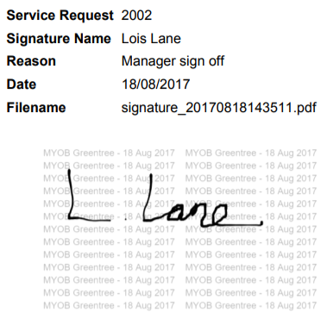

Enhancements – Greentree Desktop

Tax File Declaration Changes for Working Holiday Makers (Australia)
On 1 January 2017, the ATO changed to the way it taxes Working Holiday Makers — learn more at the ATO website. We've updated the HR Employee Maintenance form to reflect those changes.
We've simplified the Tax File Number Declaration section on the Tax Config tab:
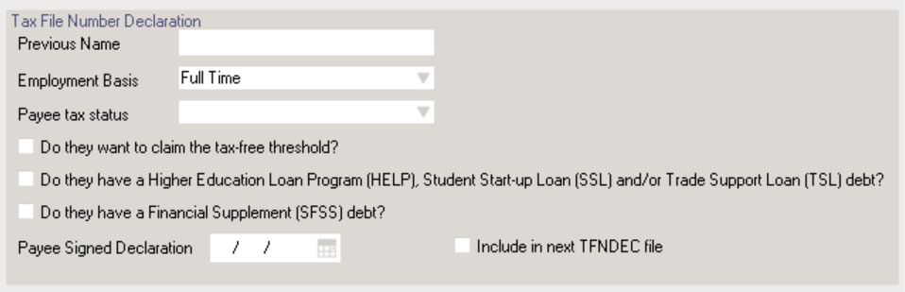
The tax offset options have been removed from the form, and the Payee tax status droplist replaces the Australian Resident checkbox. Use this droplist to specify whether the employee is an Australian resident, a foreign resident, or a working holiday maker.
We've also updated the Create TFN Declaration File form to allow you to choose the version of the TFN Declaration file that you want submit to the ATO:
- 3.0 - The TFN file that the ATO expects from 30 September 2017 onwards if the employee is a working holiday maker.
- 2.3 - You can continue to use this version of the TFN file after 30 September 2017 if the employee isn't a Working Holiday Maker.
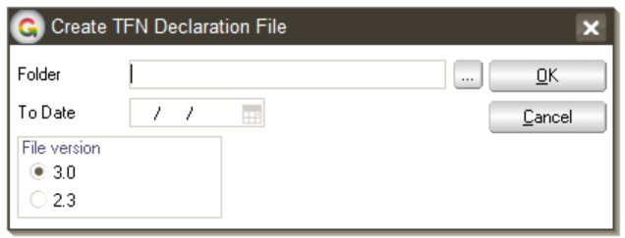
You can find these changes under HR > Employee Maintenance > Tax Config and under HR > Payroll > Other Functions > Create TFN Declaration File.

Custom Tab Added to JC Job Templates
Job Managers can now create jobs from templates that are pre-populated with trees (which let you categorise and group masterfiles) and user-defined fields.
You set this up by:
- Adding trees to templates on System > Trees > Tree Maintenance, then selecting JC Jobs option from the Use column in the Zone list
- Adding user-defined fields to templates via the System > Job Cost > Job User Field Maintenance form
The trees and user-defined fields appear on the Custom tabs of the following forms:
- Data Entry > Job Cost > Job Maintenance
- Data Entry > Job Cost > Template Maintenance
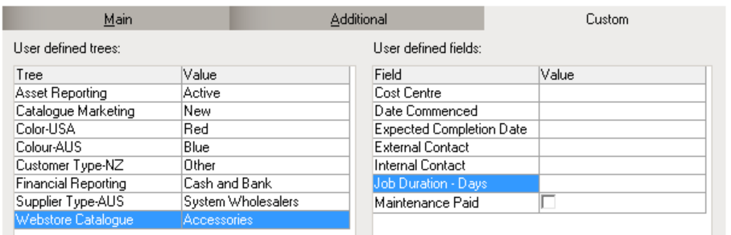
You can configure values for the trees and user-defined fields as needed on the Custom tab. For example if you're selling software you can set the Supplier Type tree to Software Wholesalers and the Webstore Catalogue tree to Software.
New jobs that you create from a template will use the settings on the Custom tab.

Enhancements – Greentree Browser
Browser Employees Can Work with HR Incidents —Employees can now create, view, and edit HR incidents in Greentree Browser. An employee can use this function if:
- They are a Browser Employee
- The Incident option on the HR Employee tab of the Mobile Employee Maintenance form is selected
- Any of their companies uses the HR Occupational Health and Safety module

- Employees can only work with the incidents they’ve reported.

Enhancements – Greentree Browser and Desktop

Inactive Accounts No Longer Visible on Forms
Previously, Greentree returned inactive employees, managers, and suppliers in search results but only indicated they were inactive when you selected them.
Now, the names of inactive employees, managers, and suppliers do not appear on forms in the following Greentree Browser and Desktop modules:
Type of Account | Greentree Browser Module | Greentree Desktop Module
Salesperson | - Sales Order  - Sales Quote  - Service Quote | - Sales Order  - Sales Quote
Supplier |  | - Purchase Order Entry  - Purchase Order  - Standing Order  - AP Standing Invoice  - Sales Quote  - Requisitions
Job Manager/Account Manager | - Call  - Service Request  - Sales Quote | - JC Job Maintenance  - JC Job Template  - Sales Quote
For JC Jobs, the following also applies:
- In the JC Job Maintenance and JC Job Template windows, inactive Job Manager and Account Managers are hidden. Inactive employees appear on existing jobs and templates, but you can't select them
- If you're creating a job from a template with an inactive manager, the Job Manager or Account Manager field is blank
- When a JC Job is automatically created from a Call or a Service Request, if the manager is inactive then the Job Manager or Account Manager field is blank
- When importing a JC Job using FREE, an error displays if the Job Manager or Account Manager is inactive. The import fails
- When a JC Job is created from a Call or Service Request and the template has an inactive Job Manager or Account Manager, Greentree Browser saves the Call or Service Request. However, it doesn't create the job. An error displays and you must either edit the template or assign the job to the Call or Service Request in Greentree Desktop.

