How to add Estimate Sub Report to Quote Report
- Add Footer section below detail section 2 marked by the large arrow in the attached Estimate Sub report .png file and named EstimatesDetail.
- Insert the sub report, SO6411AM.rpx in the new footer.
- Set the height of the new footer to 0.16667in.
- To show or hide the Estimates section based on whether or not there are estimates on the order, set the Visible Expression of the new footer to the following value: =([SOOrder.AMCuryEstimateTotal] <> Null And [SOOrder.AMCuryEstimateTotal] <> 0)
- Add two new text boxes in the groupFooterSection1 marked by smaller arrow in the picture. You can use the same Visible Expression used for the Estimate details to show them only when Estimates exist for the order.
- Optionally you can add another footer as shown placing the new text boxes in the new footer labeled EstimateTotals and use the Visible Expression to show the footer with the added text boxes when Estimates exist and the Standard footer when there are no Estimates on the order. The Visible Expression for the standard report footer is set to the following value: =([SOOrder.AMCuryEstimateTotal] = Null Or [SOOrder.AMCuryEstimateTotal] = 0)
- The value for the Estimate Total is “=[SOOrder.AMCuryEstimateTotal]”

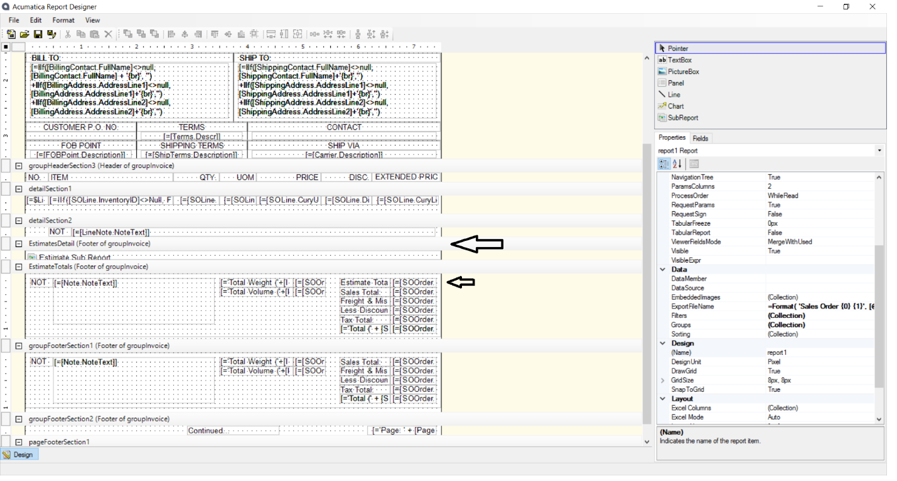

Sample Report
The sample report (SO641000.rpx) provided by JAMS is attached to the help article. You can use this as template to modify your existing Quote form or if you do not have a modified version, use this report and tailor it to your needs.

Line Example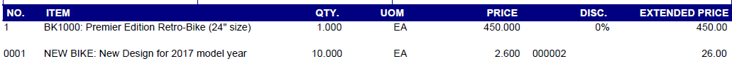
The indicated line is from the Estimate tab of the Sales Quote

Total Example
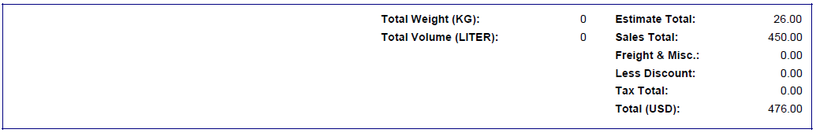
The total of all estimates is added to the total area.

